100

102

102B

102BA
102BB

102A

102AC
102AB
102AA

104
106

108

110

Figure 1

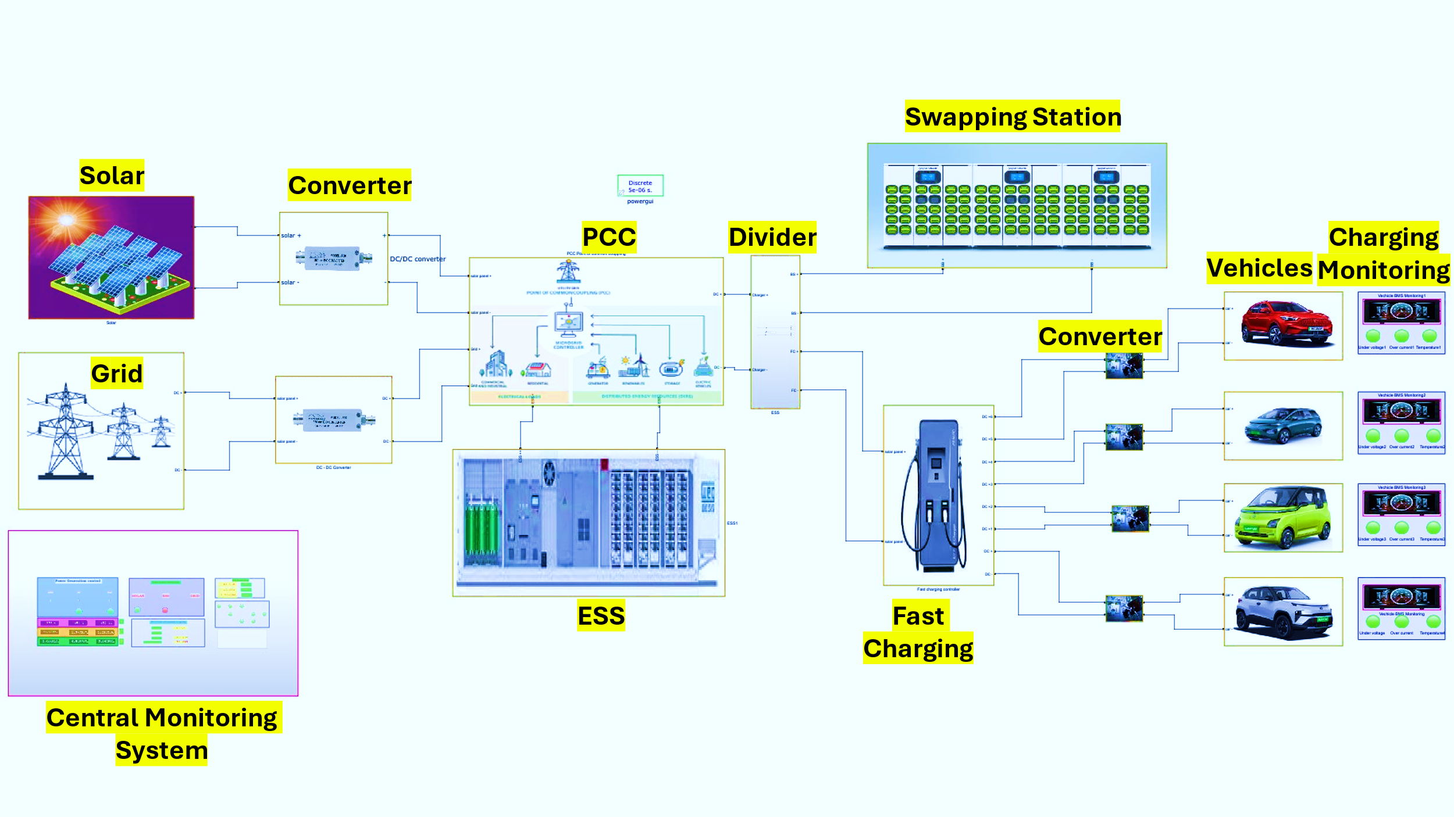
Figure 2

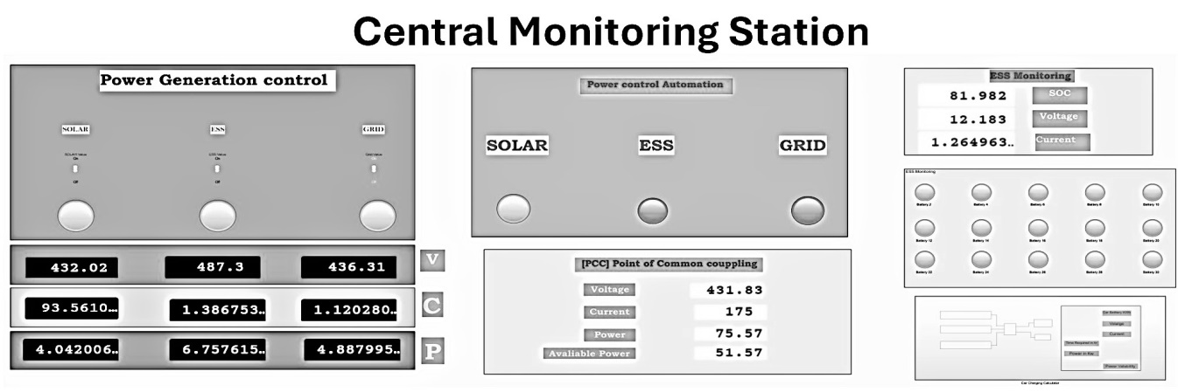
Figure 3A
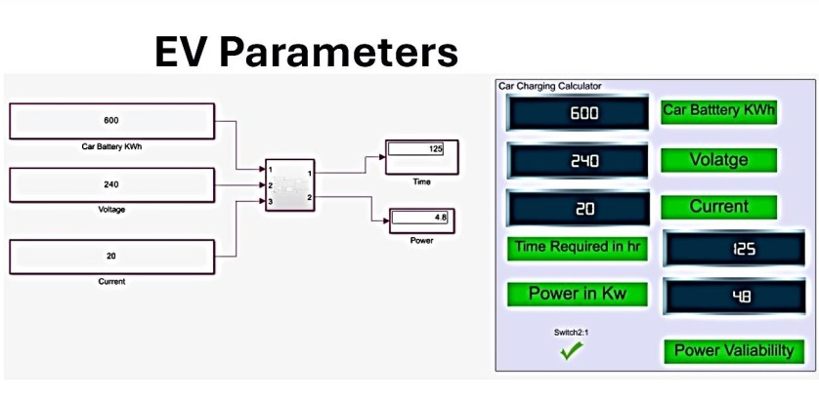
Figure 3B
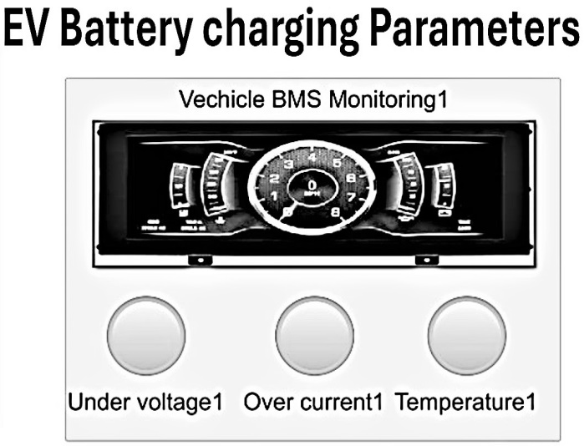
Figure 3C

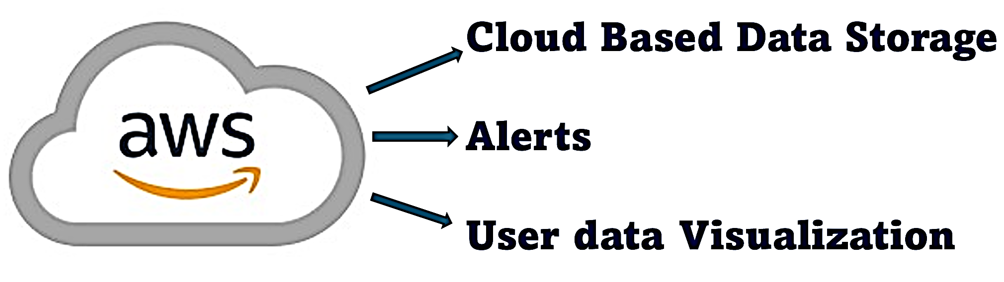
Figure 4

Figure 5

600
collecting, from plurality of sensors (102A), real-time data in a device layer (102), including energy availability, battery SOC, and load conditions;
602

604
transmitting, via a network layer (104), the collected data to an edge computing layer (106);

606
106
Figure 2
processing, the data at the edge computing layer (106) to determine energy source switching operations, and balance loads across charging units based on pre-defined automation rules;

608
transmitting, the processed data and operational commands to the device layer (102) for execution and to the cloud layer (108) for storage and analytics;

610
analyzing, the data in the cloud layer (108) to predict energy demand and availability, and optimize charging schedules based on user preferences; and

612
displaying, real-time system status, analytics, and recommendations on a user interface in the application layer (110).

Figure 6

